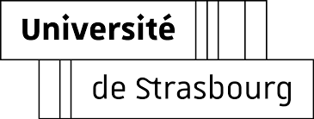
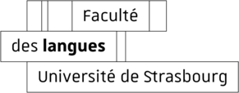

Le département d’études néo-helléniques

organise le séminaire donné par

Georgia Gotsi

Associate Professor of Modern Greek & Comparative Literature
Department of Philology
University of Patras

mardi 10 avril 2018
à 12h
Le Patio, salle 4307

The Caryatids’ Lament: “The Elgin Marbles” in Greek Literary Imagination

In the early 19th century Lord Elgin removed one of the female figures of the Caryatid Porch of the Erechtheum on the Athenian Acropolis. Shortly thereafter European travelers recorded a popular narrative according to which the “Korai” who had been left behind mourned for the loss of their sister; she responded with a lament of her own. Since then the tale of the “Caryatids’ Lament” has become an emblematic case of an ancient monument’s symbolic and formal modes of transcription and, in its different forms of telling and retelling, it has generated a cross of colonial and national discourses. In her talk, Georgia Gotsi shall examine the various layers, contradictory and overlapping in time, of this living archaeological tale.

